Tectonic Destinations

Travel Brochure
By: Wendy Chen 810

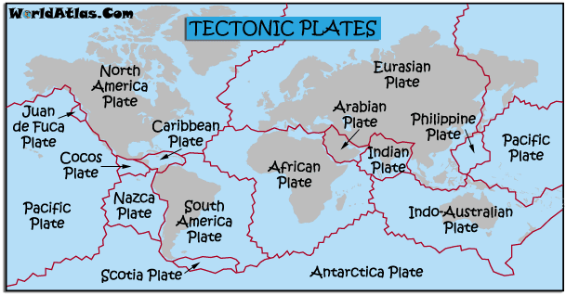
Tectonic Plates of the World

Background Information:
From the deepest ocean trenches to the tallest mountains, have you ever wondered how some of these features on Earth are formed? Tectonic plates are broken pieces of the Earth’s lithosphere, which is the outermost shell of the planet (where the crust and the upper part of the mantle lies). There are two types of tectonic plates: continental plates and oceanic plates. There is a theory called Plate Tectonics that was created in 1968 and it explained that the Lithosphere is split into seven to twelve major plates that move about 2-15 cm per year (at the rate that fingernails grow). Between the tectonic plates’ boundaries, they move by sliding, colliding, or spreading.
Tectonic plates move because it on top of the flowing mantle or otherwise known as the asthenosphere. The asthenosphere is the layer of Earth that lies below the Lithosphere. The asthenosphere is made of solid rock, however the rocks can flow like liquid because there is a lot of pressure and heat in the asthenosphere. Because the rocks can flow like liquid, there are usually convection currents happening in this layer of Earth, moving the mantle. The hot rock rises, gives off some heat, and then falls. This moves the plates of crusts on top.
The theory of plate tectonics was one of the most important scientific theory because it contributed to another theory called Continental Drift. The continental drift was first proposed by Alfred Wegener and it stated that the continents were once together in one landmass called Pangaea. However, this theory was rejected by other scientists because Wegener couldn’t explain the “how” of the theory or the driving force. The theory of plate tectonics supported the “how” of the theory of continental drift (saying that if the tectonic plates move and it’s below the continents, then the continents would move too).
Since you’ve learned so much about tectonic plates and its theories already, you’ll be visiting 5 different tectonic locations and discover its importance.

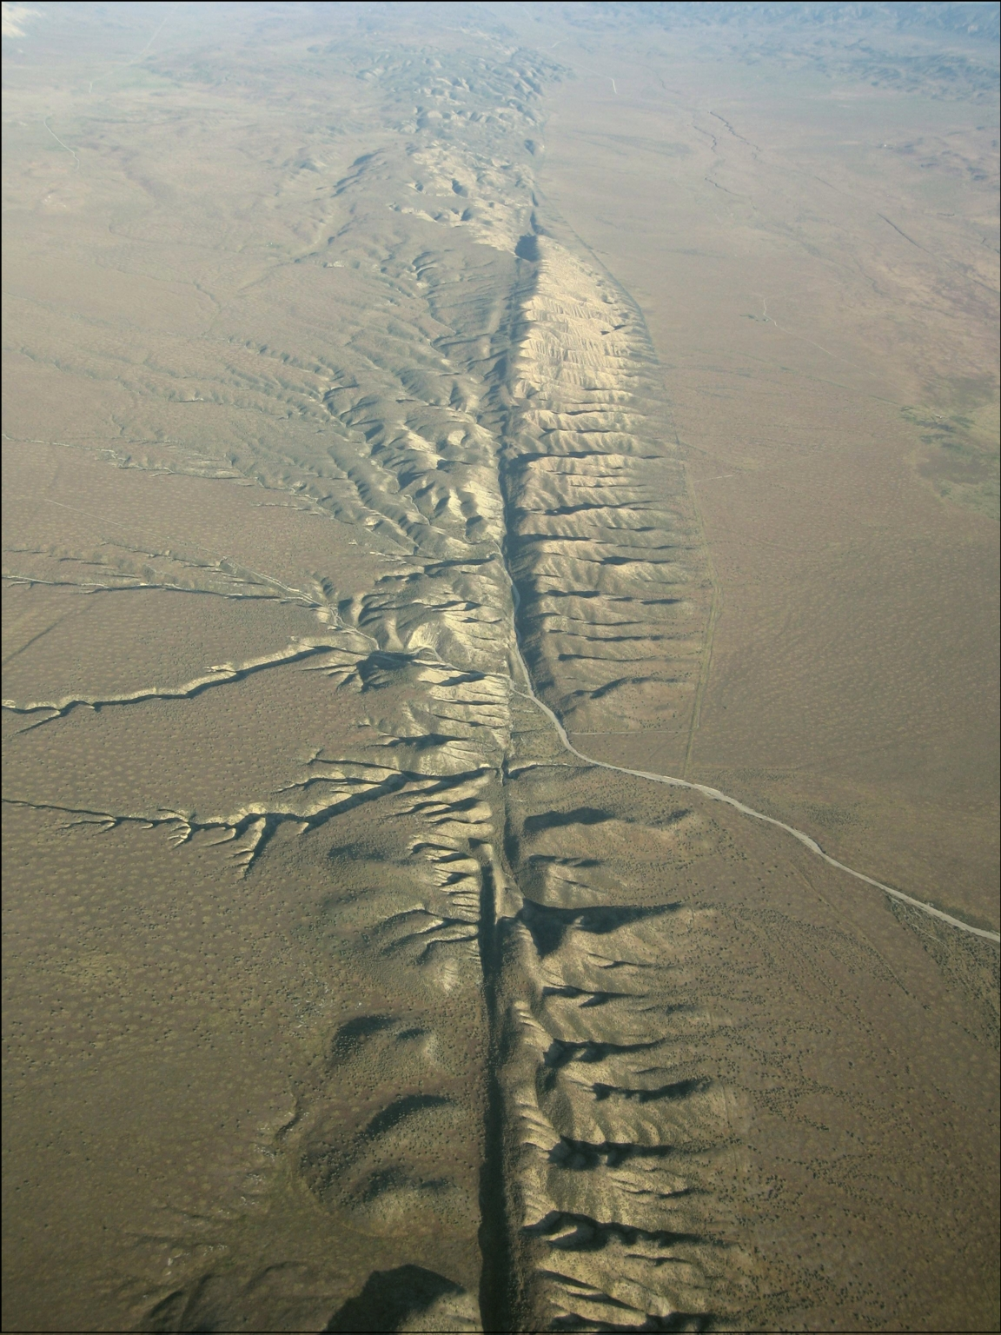
Destination 1:
The San Andreas Fault
The San Andreas Fault is an active transform plate boundary and maybe one of the most well-known transform boundary, which means the plates are sliding past one another in opposite direction. It forms the tectonic boundary between the Pacific plate and the North American Plate. The Pacific plate (carrying the city of Los Angeles) is moving northwards with respect to the North American Plate. The San Andreas Fault is divided into three segments (northern, central, and southern). Faulting happens in this site and that is why there is such a big fault. The type of fault in the San Andreas Fault is an example of strike slips. Strike slips are basically when two plates are moving horizontally (left to right). Additional to faults, there are other landforms in this site like cliffs, valleys and also some volcanic mountains.
Geologists would find this site interesting because they could study the fractures and to predict earthquakes. The San Andreas Fault is known for many earthquakes, exceeding 8.0, and can cause lots of damage. Travelers would find this site enjoyable because there is an “earthquake walk” that is on the actual fault, offering interesting insights.

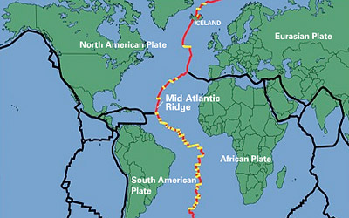
Destination 2:
The Mid Atlantic Ridge
Our first destination is the Mid Atlantic Ridge, which is an unique system that separates the North American plate and the South American Plate in the west from the Eurasian Plate and African Plate in the east. Located along the seafloor of the Atlantic ocean and Iceland, the Mid Atlantic Ridge is probably one of the most famous, active divergent plate boundary, meaning that two plates are moving away from each other. There are a lot of tectonic activities that are found at this site. These include seafloor spreading, rifting, and volcanic activities. Rift valleys are created due to these tectonic activities (and some are volcanic mountains too).
Geologists will find this site very interesting because much of the Mid Atlantic Ridge has still remained a mystery and studying the geological features and the ocean there could give us clues on new discoveries. The site is geologically important because the Mid Atlantic Ridge occur along the kind of plate boundary where new ocean floor is created as plates spread apart (seafloor spreading). Additionally, since there are volcanic activities at this site, the heat from the volcanoes and the waters provide energy and life for the community of deep sea animals. They do not rely on the sun like usual creatures. Furthermore, travelers would enjoy exploring the fascinating nature and the walk along the mountains created.

Destination 3:
Cascadia Subduction Zone
The Cascadia Subduction Zone is also referred to as the Cascadia fault. This is where the oceanic Juan de Fuca, Gorda and Explorer Plates subduct under the continental North American plate. The Cascadia Subduction Zone is a convergent plate boundary that stretches from northern Vancouver Island to northern California. Since this is a continental/oceanic plate boundary, then subduction will be found on this site. There is also volcanic activities because when subduction happens, magma is pushed upwards through the cracks. Due to volcanic activity, there is a volcanic island arc called the Cascade Volcanic Arc that extends from northern California to British Columbia. In this volcanic arc, there are chains of well-known peaks like Mt.Helens, Mt.Rainer, and etc.
Geologists would find this site very interesting because this site is known for its massive earthquake destructions. The last great earthquake was the 1700 Cascadia earthquake. There was evidence that this earthquake had more than a magnitude of 8.0. The Cascadia Subduction Zone also has a connection with another fault called the San Andreas Fault. It would be interesting for geologists to predict the next major earthquake that will hit. Furthermore, travelers would enjoy exploring the mysterious ghost forests in the Cascadia fault. The ghost forests may indicate about earthquakes long time ago in the Cascadia Subduction Zone.
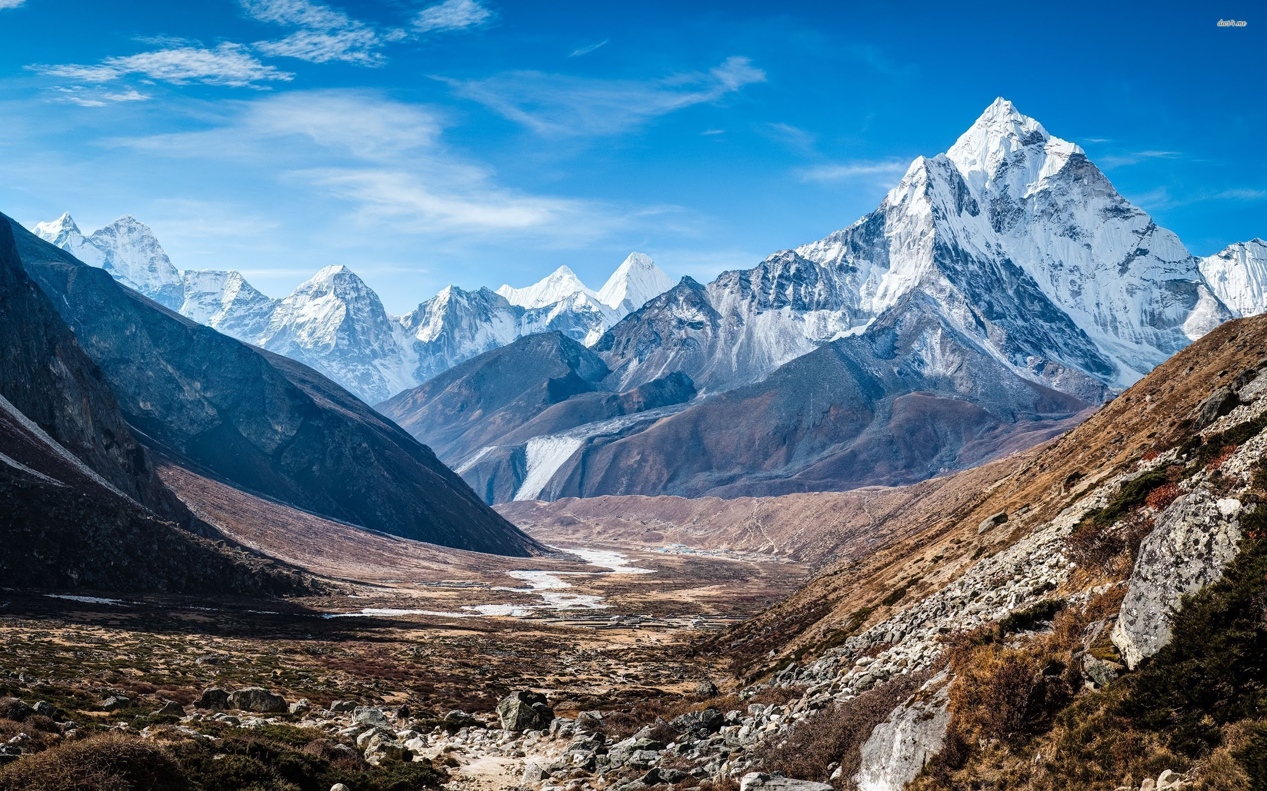
Destination 4:
The Himalayas
Another type of convergent plate boundary is a continental plate colliding with another continental plate (orogenic belt). Orogeny is the process of mountain formation, especially by folding or faulting of the earth’s crust. The Himalayan Mountain extends in the countries of Pakistan, Nepal, India, and Tibet. The Himalayas was created by the converging of the Eurasian Plate and the Indian Plate. There is folding that you can find in this site and so the Himalayan Mountain is rising overtime with folding occurring.
Geologists would find this site interesting to study because the Himalayan is known for the importance of its climate effects on the Indian climate. It acts as a huge source of water for the Indian rivers, and is responsible for the agricultural. On the other hand, tourists would visit this site because of its breathtaking nature and healthy environments. Visitors could also find wildlife in the Himalayan.

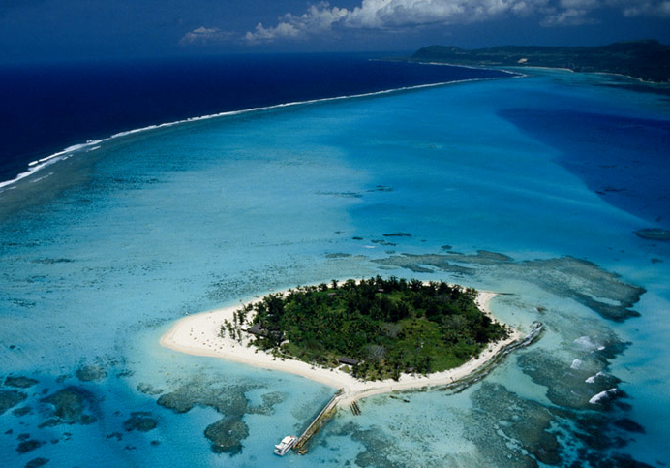
Destination 5:
The Mariana Trench
Known as the world’s deepest ocean trench, the Mariana Trench will be the last destination of this tour. The Mariana Trench is located in the western part of the Pacific Ocean. It was formed by the subducting of the Pacific Plate (an oceanic plate) under the Philippine Sea Plate (also an oceanic plate). Because subduction happens at this site, a trench is formed. A trench is like a long, narrow depression under the ocean. The Mariana Trench is about 2,550 kilometers long and a width of about 69 kilometers.

Geologists would find this site very interesting because the trench is so deep that it’s very difficult for scientists to go down that deep. The deeper the trench, the more pressure there are. It’s also amazing how there are so many undiscovered sea creatures at the bottom of this trench. There are also parts of the trench where geologists have not yet uncovered because they can’t dive deep enough. Tourists would find this site to be fascinating because of the different sea creatures they could find in the trench.

Hope You Enjoyed This Tour!

Come Join Us Next Time

